|  |  |
| --- | --- |
| **Project Code:** | BS-01 |
| **Project Name:** | BANKING SYSTEM |

|  |  |  |  |  |
| --- | --- | --- | --- | --- |
|  |  |  |  |  |
| **Prepared by/Date** |  | **Reviewed by/Date** |  | **Approved by/Date** |

**Revision History**

|  |  |  |  |  |  |
| --- | --- | --- | --- | --- | --- |
| **Version (x.yy)** | **Date of Revision** | **Description of Change** | **Reason for Change** | **Affected Sections** | **Approved By** |
| 1.0 | 26.04.13 | Initial Draft |  |  |  |
| 2.0 | 25.07.14 | Revision | Mapping with UCF |  |  |
|  |  |  |  |  |  |
|  |  |  |  |  |  |
|  |  |  |  |  |  |
|  |  |  |  |  |  |
|  |  |  |  |  |  |
|  |  |  |  |  |  |

**Affected Groups**

|  |
| --- |
|  |
|  |
|  |
|  |

**List of Reference Documents**

|  |  |
| --- | --- |
| **Name** | **Version No.** |
| 1.RS_BS.pdf | 1.0 |
| 2. FS_BS.pdf | 1.0 |
| 3. |  |
| 4. |  |

**Table of Contents**

1. Introduction 5

1.1. Background 5

1.2. Purpose 5

1.3. Scope 5

2. Global Data Structures and Shared Data Functions 6

2.1. Table Design 6

2.1.1 - BS_CUSTDET_TB 6

2.1.2 - BS_USER_CRED_TB 7

2.1.3 - BS_ACCOUNTS_TB 7

2.1.4 - BS_TRANS_TB 7

2.1.5- BS_BRANCH_DET_TB 8

2.1.6 - BS_PAY_DET_TB 8

2.1.7 - BS_FIXED_DEPO_TB 9

2.1.8 - BS_REC_DEPO_TB 9

2.2. STORED PROCEDURES AND FUNCTIONS 10

2.2.1 BS_LOGIN_PROC 10

2.2.2 BS_LOGOUT_PROC 10

2.2.3 BS_CHPSW_PROC 10

2.2.4 BS_CUST_CREATE_PROC 10

2.2.5 BS_ADD_PAY_PROC 10

2.2.6 BS_ACTIVATE_PAY_PROC 10

2.2.7 BS_VIEW_PAY_PROC 10

2.2.8 BS_DELETE_PAY_PROC 10

2.2.9 BS_VIEW_ACC_PROC 10

2.2.10 BS_FUND_TRANSFER_PROC 10

2.2.11 BS_FIXED_ACC_PROC 10

2.2.12 BS_REC_ACC_PROC 10

2.2.13 BS_CLOSED_FD_PROC 10

2.2.14 BS_CLOSED_RD_PROC 10

2.2.15 BS_ACC_STATEMENT 10

2.2.16 BS_VIEW_DEPOSIT_PROC 10

3. High Level Design 11

3.1. Use-Case Diagrams 11

3.1.1 Admin Use Case 11

3.1.2 Customer Use Case 12

3.2. Use case 13

3.2.1 USER Login 13

3.2.2 USER Logout 14

3.2.3 ChanGE Password 15

3.2.4 Add Customer 16

3.2.5 Add Payee 17

3.2.6 Activate Payee ………………………………………. 18

3.2.7 View Payee Details 19

3.2.8 Delete Payee 20

3.2.9 VIEW ACCOUNT SUMMARY 21

3.2.10 GENERATE ACCOUNT STATEMENT 22

3.2.11 Fund Transfer 23

3.2.12 Creating Fixed/Recurring Deposit 24

3.2.13 Close Fixed/Recurring Deposit 25

3.2.14 view deposit 26

3.3. Class Diagram 27

3.4. Sequence Diagrams 27

3.4.2 Fund Transfer sequence 28

4. Critical Functions and Focus for Testing 29

5. Limitations 29

# Introduction

## Background

XYZ Bank provides secure online banking services to its customers.

## Purpose

XYZ Bank plans to develop “Banking System” - a web application where a customer can avail the services of the bank online.

## Scope

The scope of the Banking System (BS) will be to provide the functionality as described in Functional Requirements below. The system will be developed on a Windows operating system using Oracle database.

# Global Data Structures and Shared Data Functions

This section describes the structure of 8 tables to be used for the implementation of requirements as stated in the specification.

Table structures to be defined

## Table Design

**Tables Used In Banking System**

|  |  |  |
| --- | --- | --- |
|  | | |
|  |  |  |
|  |  |  |
| 2.1.1 – BS_CUSTDET_TB |  |  |
|  |  |  |
|  |  |  |
|  |  |  |
|  |  |  |
|  |  |  |
| 2.1.2 – BS_USER_CRED_TB |  |  |
|  |  |  |
|  |  |  |
|  |  |  |
| 2.1.3 – BS_ACCOUNTS_TB |  |  |
|  |  |  |
|  |  |  |
| 2.1.4 - BS_TRANS_TB |  |  |
|  |  |  |
|  |  |  |
|  |  |  |
|  |  |  |
| 2.1.5- BS_BRANCH_DET_TB |  |  |
|  |  |  |
|  |  |  |
|  |  |  |
| 2.1.6 - BS_PAY_DET_TB |  |  |
|  |  |  |
|  |  |  |
|  |  |  |
| 2.1.7 – BS_FIXED_DEPO_TB |  |  |
|  |  |  |

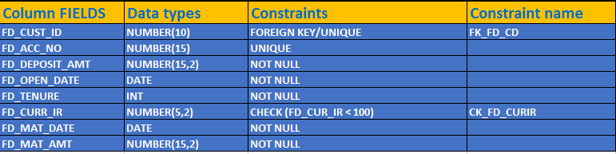

|  |  |
| --- | --- |
| 2.1.8 – BS_REC_DEPO_TB |  |

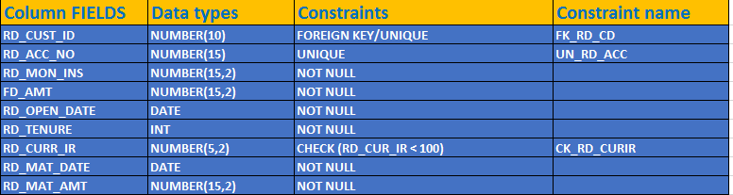

## 2.2 STORED PROCEDURES AND FUNCTIONS

### 2.2.1 BS_LOGIN_PROC

### 2.2.2 BS_LOGOUT_PROC

### 2.2.3 BS_CHPSW_PROC

### 2.2.4 BS_CUST_CREATE_PROC

### 2.2.5 BS_ADD_PAY_PROC

### 2.2.6 BS_ACTIVATE_PAY_PROC

### 2.2.7 BS_VIEW_PAY_PROC

### 2.2.8 BS_DELETE_PAY_PROC

### 2.2.9 BS_VIEW_ACC_PROC

### 2.2.10 BS_FUND_TRANSFER_PROC

### 2.2.11 BS_FIXED_ACC_PROC

### 2.2.12 BS_REC_ACC_PROC

**2.2.13 BS_CLOSE_FD_PROC**

### 2.2.14 BS_CLOSE_RD_PROC

**2.2.15 BS_ACC_STATEMENT_PROC**

**2.2.16 BS_VIEWDEPOSIT_PROC**

# High Level Design

## Use-Case Diagrams

### 3.1.1 Admin Use Case

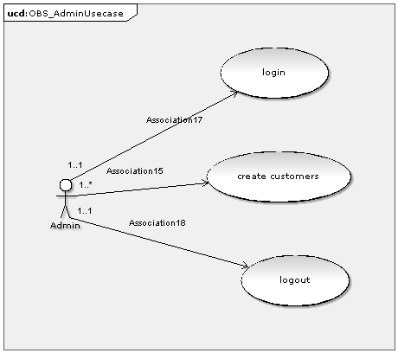

Fig. 3.1.1 Admin Use case

### 3.1.2 Customer Use Case

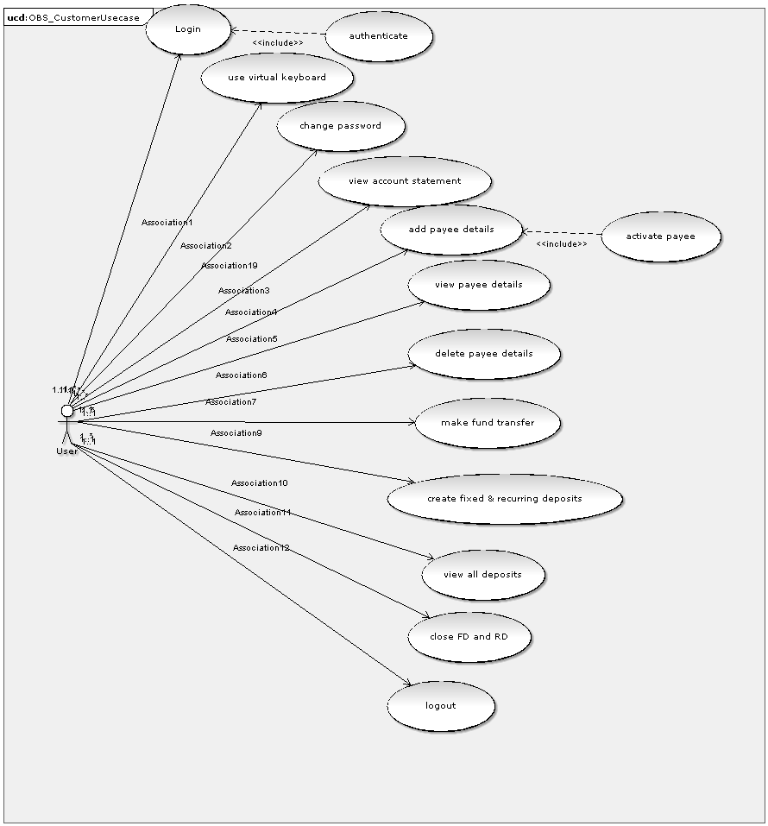

## Use Case

Generally, in a design document, Use case definitions should be written for all the *Requirements* of the system.

Note: Participants are expected to document use case definitions for all requirements. However, for few requirements documented below for reference.

**3.2.1 User Login**

|  |  |  |
| --- | --- | --- |
| **USE CASE US-001** | ***AA-001 Login*** | |
| **Goal** | *The user should able to login* | |
| **Preconditions** | *The User must have a user id and password.* | |
| **Success End Condition** | *On Success user can be able to login to his Account.* | |
| **Failed End Condition** | *Not able to login.* | |
| **Primary, Secondary Actors** | *Admin, Customer* | |
| **Trigger** | *On Clicking the login Button* | |
| **DESCRIPTION** | **Step** | **Action** |
| **1** | *Admin or Customer has to click on login Button.* |
| **2** | *Admin or Customer has to enter the username and password to login.* |
| **Step** | **Branching Action** |
| **2** | *On failure display an Error Message displaying unable to login.* |
| **Related Information/Use cases** | *-* | |
| **Priority** | *P1* | |
| **Performance** | *50 secs (depends on user entry Time)* | |
| **Frequency** | *100* | |
| **Assumptions** | *The User must have a user id and password.* | |

**3.2.2 User Logout**

|  |  |  |
| --- | --- | --- |
| **USE CASE US-002** | ***EX-001nv User Logout*** | |
| **Goal** | *The user should be able to logout from session* | |
| **Preconditions** | *The User must Be Logged in* | |
| **Success End Condition** | *On Success customer can be able to logout from the current session.* | |
| **Failed End Condition** | *No one is logged in.* | |
| **Primary, Secondary Actors** | *Admin, Customer* | |
| **Trigger** | *On Clicking the logout Button* | |
| **DESCRIPTION** | **Step** | **Action** |
| **1** | *Admin or Customer has to click on logout Button.* |
| **Step** | **Branching Action** |
| **1** | *On failure display an Error Message displaying no one logged in.* |
| **Related Information/Use cases** | *The user must have logged in.* | |
| **Priority** | *P1* | |
| **Performance** | *50 secs (depends on user entry Time)* | |
| **Frequency** | *100* | |
| **Assumptions** | *Admin or Customer is having an Account and must already be logged in.* | |

**3.2.3 Change Password**

|  |  |  |
| --- | --- | --- |
| **USE CASE US-003** | ***AA-002 Change password*** | |
| **Goal** | *The user should be able to change password.* | |
| **Preconditions** | *The User must Be Logged in* | |
| **Success End Condition** | *On Success User can be able to change his/her password.* | |
| **Failed End Condition** | *Not able to change password.* | |
| **Primary, Secondary Actors** | *Admin, Customer* | |
| **Trigger** | *On Clicking the change password Button* | |
| **DESCRIPTION** | **Step** | **Action** |
| **1** | *Admin or Customer has to click on change password.* |
| **2** | *Admin or customer has to enter the new password* |
| **3** | *The password has been changed* |
| **Step** | **Branching Action** |
| **3** | *On failure display an Error Message displaying unable to change password.* |
| **Related Information/Use cases** | *3.2* | |
| **Priority** | *P2* | |
| **Performance** | *50 secs (depends on user entry Time)* | |
| **Frequency** | *100* | |
| **Assumptions** | *Admin or Customer is having an Account and must already be logged in.* | |

**3.2.4 Add Customer**

|  |  |  |
| --- | --- | --- |
| **USE CASE US-004** | ***AD-001 Add Customer*** | |
| **Goal** | *The admin should able to create customer* | |
| **Preconditions** | *The must be logged in.* | |
| **Success End Condition** | *On Success Admin can be able to add the Customer details.* | |
| **Failed End Condition** | *Not able to add the customer* | |
| **Primary, Secondary Actors** | *Admin* | |
| **Trigger** | *On Clicking the Add Customer Button* | |
| **DESCRIPTION** | **Step** | **Action** |
| **1** | *Admin has to click on Add Customer Button.* |
| **2** | *Admin has to enter the details of the Customer.* |
| **3** | *Able to Add the customer when details are given.* |
| **Step** | **Branching Action** |
| **3** | *On failure display an Error Message displaying unable to add the customer.* |
| **Related Information/Use cases** |  | |
| **Priority** | *P1* | |
| **Performance** | *50 secs (depends on user entry Time)* | |
| **Frequency** | *100* | |
| **Assumptions** | *The admin must have logged in.* | |

**3.2.5 Add Payee**

|  |  |  |
| --- | --- | --- |
| **USE CASE US-005** | ***CU-004 Add Payee*** | |
| **Goal** | *The user can add payee.* | |
| **Preconditions** | *The User must have Logged in* | |
| **Success End Condition** | *On Success customer can be able to add the payee to his Account.* | |
| **Failed End Condition** | *Not able to add the Payee* | |
| **Primary, Secondary Actors** | *Customer* | |
| **Trigger** | *On Clicking the Add Payee Button* | |
| **DESCRIPTION** | **Step** | **Action** |
| **1** | *Customer has to click on Add Payee Button.* |
| **2** | *Customer has to enter the account number of the payee* |
| **3** | *Payee details are added* |
| **Step** | **Branching Action** |
| **1** | *On failure display an Error Message displaying unable to add the payee.* |
| **Related Information/Use cases** | *The payee should be one of the customer of the same bank.* | |
| **Priority** | *P1* | |
| **Performance** | *50 secs (depends on user entry Time)* | |
| **Frequency** | *100* | |
| **Assumptions** | *Customer is having an Account and payee must also have an account* | |

**3.2.6 Activate Payee**

|  |  |  |
| --- | --- | --- |
| **USE CASE US-006** | ***CU-005 Activate Payee*** | |
| **Goal** | *The user should be able to activate payee* | |
| **Preconditions** | *The User must have Logged in* | |
| **Success End Condition** | *On Success customer can be able to activate the payee to his Account.* | |
| **Failed End Condition** | *Not able to activate the payee* | |
| **Primary, Secondary Actors** | *Customer* | |
| **Trigger** | *On Clicking the Activate Payee Button* | |
| **DESCRIPTION** | **Step** | **Action** |
| **1** | *Customer has to click on Activate Payee Button.* |
| **2** | *Customer has to enter the payee account number to activate.* |
| **3** | *On success the payee account will be activated.* |
| **Step** | **Branching Action** |
| **1** | *On failure display an Error Message displaying unable to activate the payee.* |
| **Related Information/Use cases** |  | |
| **Priority** | *P1* | |
| **Performance** | *50 secs (depends on user entry Time)* | |
| **Frequency** | *100* | |
| **Assumptions** | *Customer is having an Account and payee details to be activated.* | |

**3.2.7 View Payee Details**

|  |  |  |
| --- | --- | --- |
| **USE CASE US-007** | ***CU-006 View Payee Details*** | |
| **Goal** | *To View Payee details* | |
| **Preconditions** | *The User must have Logged in to view payee details.* | |
| **Success End Condition** | *On Success customer can be able to view the payee in his Account.* | |
| **Failed End Condition** | *Not able to view the Payee* | |
| **Primary, Secondary Actors** | *Customer* | |
| **Trigger** | *On Clicking the View Payee Button* | |
| **DESCRIPTION** | **Step** | **Action** |
| **1** | *Customer has to click on View Payee Button.* |
| **2** | *Customer has to enter the Payee details to be viewed.* |
| **3** | *Able to Add the payee when details are submitted.* |
| **Step** | **Branching Action** |
| **3** | *On failure display an Error Message displaying unable to view the payee.* |
| **Related Information/Use cases** | *-* | |
| **Priority** | *P2* | |
| **Performance** | *50 secs (depends on user entry Time)* | |
| **Frequency** | *100* | |
| **Assumptions** | *Customer is having an Account and payee must be valid to view.* | |

**3.2.8 Delete Payee**

|  |  |  |
| --- | --- | --- |
| **USE CASE US-008** | ***CU-007 Delete Payee*** | |
| **Goal** | *The user must able to delete payee.* | |
| **Preconditions** | *The User must have Logged in to delete payee details.* | |
| **Success End Condition** | *On Success customer can be able to delete the payee in his Account.* | |
| **Failed End Condition** | *Not able to delete the Payee* | |
| **Primary, Secondary Actors** | *Customer* | |
| **Trigger** | *On Clicking the delete Payee Button* | |
| **DESCRIPTION** | **Step** | **Action** |
| **1** | *Customer has to click on delete Payee Button.* |
| **2** | *Customer enters the account number of the payee* |
| **3** | *Payee account deleted* |
| **Step** | **Branching Action** |
| **1** | *On failure display an Error Message displaying unable to delete the payee.* |
| **Related Information/Use cases** | *The payee account must be present in the payee list.* | |
| **Priority** | *P2* | |
| **Performance** | *50 secs (depends on user entry Time)* | |
| **Frequency** | *100* | |
| **Assumptions** | *Customer is having an Account and payee must be valid to delete.* | |

**3.2.9 View Account Summary**

|  |  |  |
| --- | --- | --- |
| **USE CASE US-009** | ***CU-002 View Account Summary*** | |
| **Goal** | *The user should be able to view account summary.* | |
| **Preconditions** | *The User must have account transactions to display summary* | |
| **Success End Condition** | *On Success the account summary is displayed.* | |
| **Failed End Condition** | *Not able to display account details.* | |
| **Primary, Secondary Actors** | *Customer* | |
| **Trigger** | *On Clicking the Account Summary Button* | |
| **DESCRIPTION** | **Step** | **Action** |
| **1** | *Customer has to click on Account Summary Button.* |
| **2** | *Customer has to enter the details of the account to get account summary.* |
| **Step** | **Branching Action** |
| **2** | *On failure no one is logged in.* |
| **Related Information/Use cases** |  | |
| **Priority** | *P1* | |
| **Performance** | *50 secs (depends on user entry Time)* | |
| **Frequency** | *100* | |
| **Assumptions** | *Customer is having an Account and should contain account transactions to display summary.* | |

**3.2.10 Generate Account Statement**

|  |  |  |
| --- | --- | --- |
| **USE CASE US-010** | ***CU-003 Generate Account Statement*** | |
| **Goal** | *The user should be able to generate account statement* | |
| **Preconditions** | *The User must have Logged in* | |
| **Success End Condition** | *On Success customer can be able to generate account statement.* | |
| **Failed End Condition** | *Not able to generate account statement* | |
| **Primary, Secondary Actors** | *Customer* | |
| **Trigger** | *On Clicking the account statement Button* | |
| **DESCRIPTION** | **Step** | **Action** |
| **1** | *Customer has to click on Account Statement Button.* |
| **2** | *Customer has to enter the details of the account so that it generates the statement of the current account.* |
| **Step** | **Branching Action** |
| **2** | *On failure display an Error Message displaying unable to generate the account statement.* |
| **Related Information/Use cases** | *-* | |
| **Priority** | *P1* | |
| **Performance** | *50 secs (depends on user entry Time)* | |
| **Frequency** | *100* | |
| **Assumptions** | *Customer is having an Account and its transaction details.* | |

**3.2.11 Fund Transfer**

|  |  |  |
| --- | --- | --- |
| **USE CASE US-011** | ***CU-008 Fund transfer*** | |
| **Goal** | *The user should able to transfer funds to another account.* | |
| **Preconditions** | *The User must have Logged in to transfer funds* | |
| **Success End Condition** | *On Success customer can be able to transfer the fund to an Account.* | |
| **Failed End Condition** | *Not able to transfer the fund.* | |
| **Primary, Secondary Actors** | *Customer* | |
| **Trigger** | *On Clicking the fund transfer Button* | |
| **DESCRIPTION** | **Step** | **Action** |
| **1** | *Customer has to click on fund transfer Button.* |
| **2** | *Customer has to enter the details of the funds to be transferred.* |
| **3** | *Able to transfer funds when details are submitted.* |
| **Step** | **Branching Action** |
| **3** | *On failure display an Error Message displaying unable to make a transaction to an account.* |
| **Related Information/Use cases** | *The user must have a payee account activated.* | |
| **Priority** | *P1* | |
| **Performance** | *50 secs (depends on user entry Time)* | |
| **Frequency** | *100* | |
| **Assumptions** | *Customer is having an Account to make a fund transaction to another account.* | |

**3.2.12 Creating Fixed/Recurring Deposit**

|  |  |  |
| --- | --- | --- |
| **USE CASE US-012** | ***CU-009 Creating Fixed/Recurring deposit*** | |
| **Goal** | *The user should be able to create fixed/recurring deposit account.* | |
| **Preconditions** | *The User must have Logged in to create a deposit account* | |
| **Success End Condition** | *On Success customer creates Fixed /Recurring deposit to his Account.* | |
| **Failed End Condition** | *Not able to create deposit details* | |
| **Primary, Secondary Actors** | *Customer* | |
| **Trigger** | *On Clicking the Fixed and Deposit button* | |
| **DESCRIPTION** | **Step** | **Action** |
| **1** | *Customer has to click on Fixed and Deposit button.* |
| **2** | *Customer has to enter the details for creating fixed and deposit account.* |
| **Step** | **Branching Action** |
| **2** | *On failure display an Error Message displaying unable to create account.* |
| **Related Information/Use cases** | *-* | |
| **Priority** | *P1* | |
| **Performance** | *50 secs (depends on user entry Time)* | |
| **Frequency** | *100* | |
| **Assumptions** | *Customer is having an Account to create Fixed and Recurring deposit account* | |

**3.2.13 Close Fixed/Recurring Deposit**

|  |  |  |
| --- | --- | --- |
| **USE CASE US-013** | ***CU-010 Closing Fixed/Recurring deposit*** | |
| **Goal** | *The user should be able to close fixed/recurring deposit account.* | |
| **Preconditions** | *The User must have Logged in to close a deposit account* | |
| **Success End Condition** | *On Success customer closes Fixed and Recurring deposit to his Account.* | |
| **Failed End Condition** | *No deposit account exists* | |
| **Primary, Secondary Actors** | *Customer* | |
| **Trigger** | *On Clicking the Close Fixed / Recurring Deposit button* | |
| **DESCRIPTION** | **Step** | **Action** |
| **1** | *Customer has to click on close Fixed/recurring Deposit button.* |
| **2** | *Customer has to close fixed / recurring deposit account.* |
| **Step** | **Branching Action** |
| **1** | *On failure display an Error Message displaying unable to close deposit details.* |
| **Related Information/Use cases** | *The Customer must have a fixed / recurring account to close.* | |
| **Priority** | *P1* | |
| **Performance** | *50 secs (depends on user entry Time)* | |
| **Frequency** | *100* | |
| **Assumptions** | *Customer is having an Account to close Fixed and Recurring deposit account* | |

**3.2.14 View Deposit**

|  |  |  |
| --- | --- | --- |
| **USE CASE US-014** | ***CU-011 View Deposit*** | |
| **Goal** | *The user should be able to view deposit account details.* | |
| **Preconditions** | *The User must have Logged in to view deposit details* | |
| **Success End Condition** | *On Success customer can be able to View deposit details in his Account.* | |
| **Failed End Condition** | *Not able to view the deposit details.* | |
| **Primary, Secondary Actors** | *Customer* | |
| **Trigger** | *On Clicking the View Deposit Button* | |
| **DESCRIPTION** | **Step** | **Action** |
| **1** | *Customer has to click View Deposit Button.* |
| **2** | *The Details of Deposit is displayed.* |
| **Step** | **Branching Action** |
| **2** | *On failure display an Error Message displaying deposit.* |
| **Related Information/Use cases** | *Admin cannot use this option.* | |
| **Priority** | *P1* | |
| **Performance** | *50 secs (depends on user entry Time)* | |
| **Frequency** | *100* | |
| **Assumptions** | *Customer is having an Account and any deposit is activated.* | |

## Class Diagram

The class diagram is a very basic concept in object-oriented world. Class diagrams demonstrate a model, describing what attributes and behavior it has rather than describing the methods for accomplishing operations. Class diagrams are very useful in representing relationships between classes and interfaces.

## Sequence Diagrams

A graphical representation of a module’s function invoking functions of other modules in order to achieve a task (specific user requirement) is called a sequence diagram. A sequence diagram for the authentication process is given below for reference. The below example is for a Web Application using servlet/jsp.

**3.4.1 Add Customer details:**

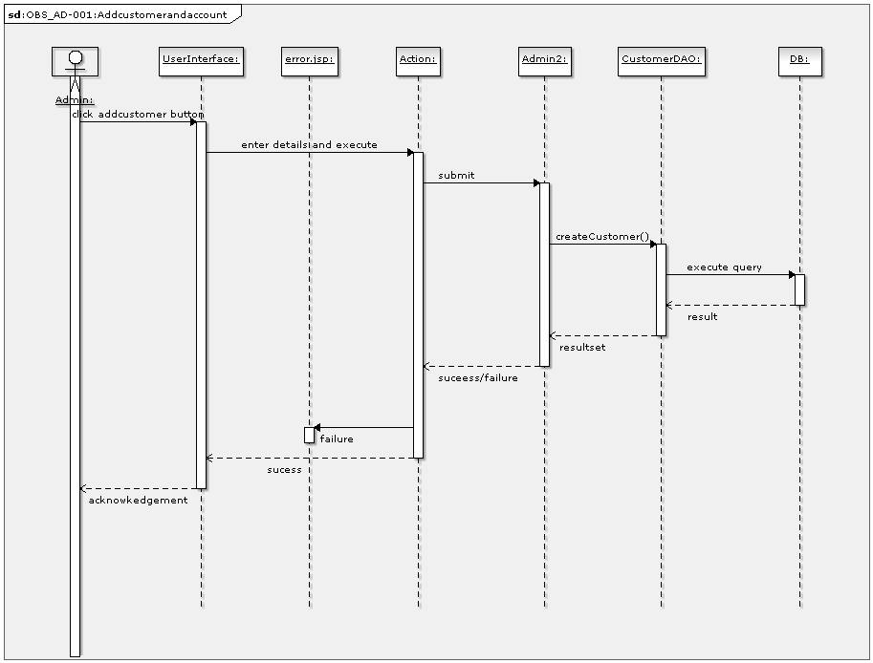

### 3.4.2 Fund Transfer sequence

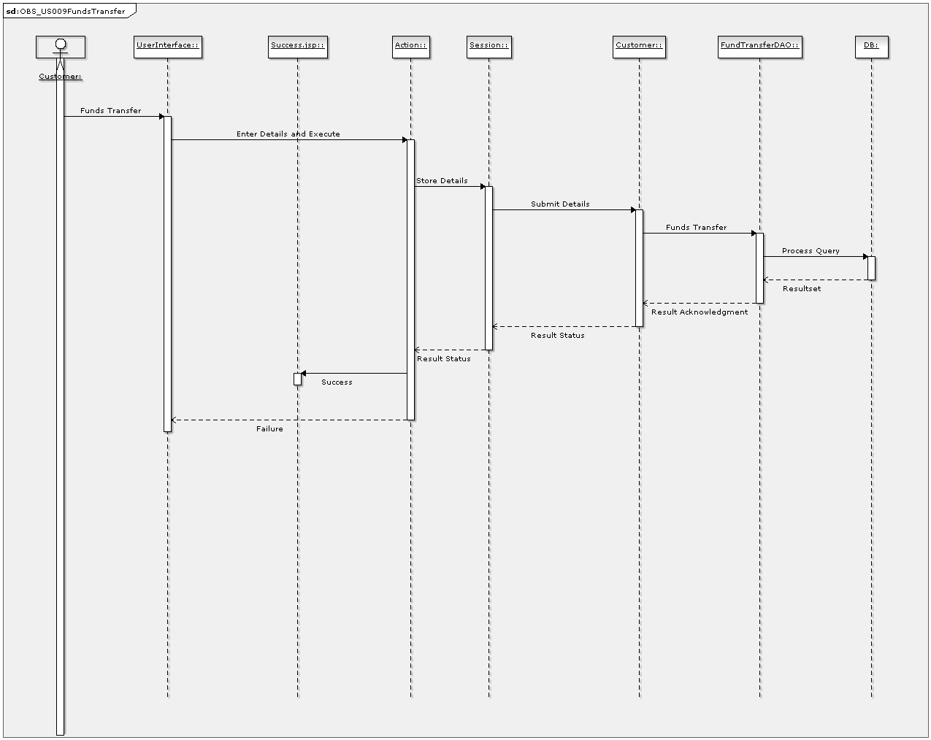

# Critical Functions and Focus for Testing

* Login Handling
* Log out Handling
* Create Customer
* Activation of payee
* Fund Transfer
* Fixed Deposit and Recurring Deposit Accounts Handling
* To Transfer funds payee must already be activated.

# Limitations

* Customer is limited to have maximum of 2 accounts per branch.
* Fund transfer should be within the same branch / bank.
* Customer is allowed to have only one Fixed and Recurring deposit.
* Minimum Tenure period of deposit accounts is 6 months.